Dates will be added to this on a weekly basis, please do keep referring back here for updates.

**Faith Life**

*Our virtues this half-term are:* ***Learned and wise***

The Primary School Wednesday Word is an outreach which shares Sunday's Gospel with all school families, in a unique way. This is a weekly Gospel 'gift' from the school to the child to take home, which then becomes a 'gift' from the child to the whole family.

<http://www.wednesdayword.org/school/index.htm>

**Term dates for 2023-2024 including training days have been added to the end of this newsletter.**



**Summer Term**

**Twitter:** @GregoryPrimary



Remember to follow the official school twitter account to get updates of celebrations of work and events across the curriculum.

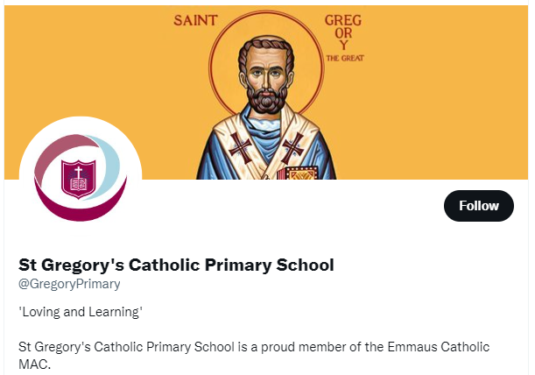

**Sandwell Family Life Website**

[**https://www.healthysandwell.co.uk/**](https://www.healthysandwell.co.uk/)

**Week beginnng 26th June**

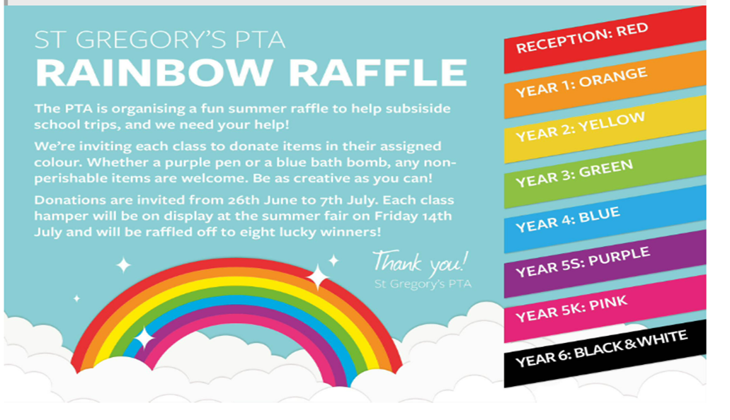

**Monday 26th June:** Sports day Reception and Year 1 9: 15a.m. start

Classes 2 & 3 sports 1:15pm, all parents welcome.

The PTA are going to be selling refreshments at both sports days, please bring cash donations.

**Monday 26th:** Girls football afterschool club 3.30-4.30

**Tuesday 27th:** Lego club

**Wednesday 28th:** Pre school sports day 10a.m parents/carers welcome

**Wednesday 28th:** Class 6 swimming

**Wednesday 28th June:** theatre trip for Classes 3, 4 and 5.Children will return to school at approximately 4.15p.m.

**Thursday 29th :** *Feast of St Peter and St Paul,* Mass for Reception, Classes 1 & 2. All families are invited to join for this celebration in the school hall at 9.30a.m.

**Thursday 29th:** Years 4-6 Sports morning at Our Lady of Fatima School 9:30a.m start. All parents welcome. The PTA are going to be selling refreshments please bring cash donations.

**Friday 30th:** Irish dancing 3:30p.m.

**Week beginning 3rd July**

**Wednesday 5th: No** Class 6 swimming

**Wednesday 5th:** Year 7 transition day

**Wednesday 5th:** Nursery graduation ceremony 10a.m. in the school hall

**Thursday 6th:** Class 6 trip to lazer quest

**Thursday 6th:** Mass for Classes 3 & 4 all families are invited to join in this celebration at 9.20a.m.

**Friday 7th:** Final Irish dancing session

**Week beginning 10th July**

**Monday 10th:** Summer fun day for Pre school, Reception and Class1. Details from class teachers

**Tuesday 11th:** Class 6’s end of year performance, there will be an afternoon performance at 2pm and an evening performance at 6pm. Families of Class 6 children are welcome.

**Wednesday 12th:** Class 6 final swimming lesson

**Wednesday 12th:** Transiton afternoon for whole school.

**Wednesday 12th:** 5pm, Induction meeting in the hall for 2023-2024 intake pre school and Reception class

**Thursday 13th:** Mass for Classes 5 & 6 all families are invited to join in this celebration at 9.30a.m. in the school hall.

**Friday 14th:** PTA summer fair. 3:30pm.-6p.m.

**Week beginning 17th July**

**Thursday 20th:** Mass for Reception and Class 6 all families are invited to attend this celebration in the hall at 9.20a.m.

**Friday 21st:** Reception Class talent show at 1.30pm, all parents of children in Reception are welcome.

**Week beginning 24th July**

**School closes for the summer break at 3.25pm on Tuesday 25th July 2023**

**School term dates for 2023-2024**

|  |  |
| --- | --- |
| **Autumn term 1 Monday 4 Sept - Friday 27 October**  **Autumn term 2 Monday 6 November - Friday 22 December**  **Spring term 1 Monday 8 January - Friday 9 February**  **Spring term 2 Monday 19 February - Friday 22 March**  **Summer term 1 Monday 8 April - Friday 24 May**  **Summer term 2 Monday 3 June - Monday 22 July** | **Staff inset days, school closed to children**  1. Monday 4th September 2023  2. Tuesday 5th September 2023  3. Friday 6th October 2023  4. Friday 9th February 2024 (MAC wide training day)  5. Monday 22nd July 2024 (training day) |